

MAKERERE UNIVERSITY

COLLEGE OF COMPUTING AND

INFORMATION SCIENCES

**BSE 230**1 **PROFESSIONAL SOFTWARE ENGINEERING MINI PRACTICAL**

**PROJECT II**

**REPORT**

**SUPERVISOR** MR. GRACE KAMULEGEYA

|  |  |  |
| --- | --- | --- |
| NAME | REGISTRATION NO. | STUDENT NO. |
| Kisa Jeremiah | 17/U/5250/EVE | 217017394 |
| Gyagenda Arafat | 17/U/4117/EVE | 217003258 |
| Lwanga Darline | 17/U/5836/EVE | 217017397 |
| Kyadondo Solomon | 17/U/5538/EVE | 217017395 |

**Report for analysis made from the data collected from Nairobi traffic Data.**

**Introduction**

Analysis was made to Nairobi Traffic data which was got from a survey made by Uber and Mobiticket transport companies to estimate the number of public transport users coming in to Nairobi. There were over 50,000 records from different people using either shuttle or bus. The data was organized, there was no missing information or even repeated records which reduced the redundancy and caused less interference in the analysis.

**Methods for Analysis**

During our analysis we used Python programming language. We used different libraries here which helped us tackle the problems we needed to find out. We used the main library **Pandas** which gave us a set of tools for data analysis and manipulate the data in different ways. We also used other libraries like **Numpy** for our numerical analysis, **Matplotlib** and **Seaborn** the graphs and pie charts.

**Results**

After the analysis carried out we came up with the following results.

**Fig 1** below shows a list of different cities from where the passengers came from to Nairobi. In total they were 14 cities with Kissi having the highest number(22607) and Kendu(1) Bay having the least number of passengers who came to Nairobi.

**Fig 1** **Fig 2**

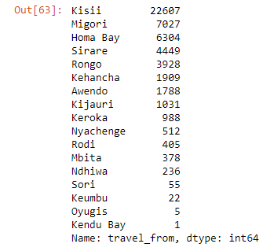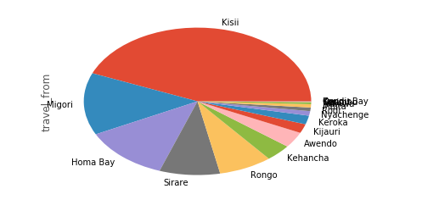

For clarity, **fig 2** shows a pie chart of fig 1 clearly showing the bigger portion for the city with the highest and smallest portion for the city that had the lowest number of passengers

**Fig 3** below shows the scatter plot for the number of travelers for the first two cities with the highest of travelers that is Kisii and Migori per travel date

**Fig 3**

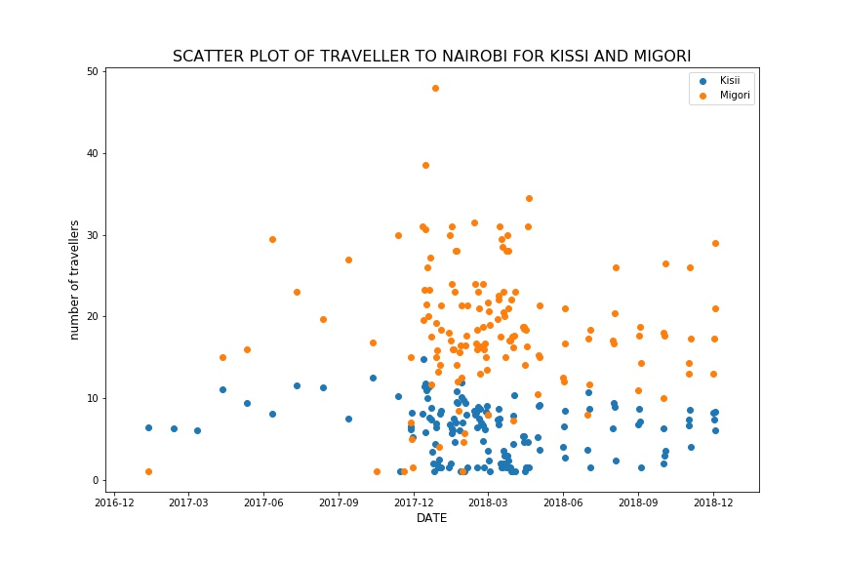

A higher number of passengers travelled between December and March and a less number with in the middle of the year.

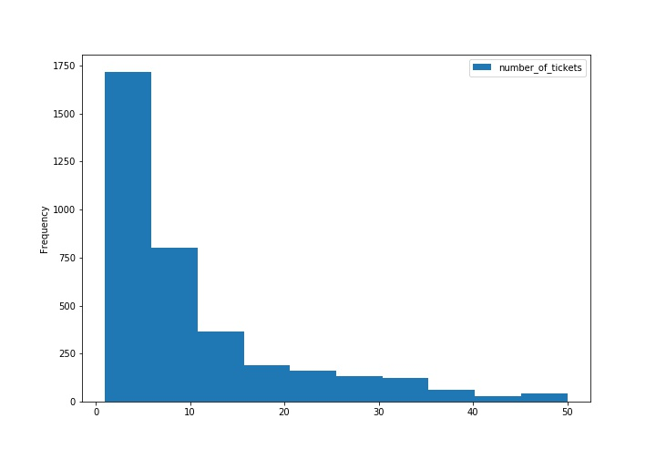**Fig 4**

**Fig 4** below is a histogram showing the frequency of the number of tickets bought by the passengers .

**Fig 5** below shows the most used modeof transportthat is between the bus and shuttle

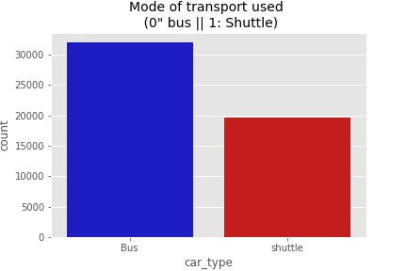**Fig 5 Fig 6**

**C:\Users\Acer\Pictures\Screenshots\Screenshot (25).png**

Here we see that the bus is mostly used by the passengers when travelling

**Fig 6** clearly shows the visual relationship between the two modes of transport

**Conclusion**

Public transport is widely used in Kenya as evidenced from this data as many tickets are sold and there is increase in population in Nairobi and with this information the government together with the road authorities in Kenya , Kenya Urban Roads Authority(KURA) to help[ improve on the roads to better the movement of people hence increasing of Kenya’s Economy.